Separation of Mixtures
Before we engage further, look at your life at home. Have you ever picked stones from rice before cooking? Have you ever poured tea through a strainer to remove the leaves? Have you ever removed cream from milk?
If your answer is YES, then you already know how to process mixtures. Separation of mixtures is one of the ways in which mixtures are processed to obtain components that are relatively pure and more useful. The good thing with mixtures is that nothing new is formed, we can always separate them and get each part back. Across Africa, we use this science every day.
Activity 1 Describing areas where separation of mixtures is applied
Work in groups
- List the different ways in which separation of mixtures is applied in our daily life. (Type HERE)
- Write a brief description on how the different applications listed above are carried out. (Type HERE)

- Share your findings with the group members for discussion.
- Obtain samples of different mixtures from your environment and carry out a separation process to obtain relatively pure components. (Take photos and short recordings of your experiments and upload HERE)
Key Points (Learner must upload all their responses to activate this section)

Separation techniques

Filtration
This technique is used to separate an insoluble solid from a liquid. It can be used to obtain a product that is free from unreacted chemicals, by-products or solvent

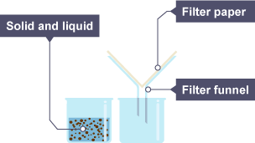

Separating insoluble solids
1. One beaker contains a mixture of solid and liquid, the other contains a funnel with filter paper
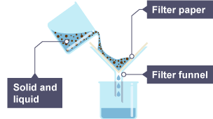

2. The solid and liquid mixture is poured into the filter funnel
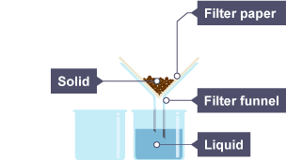
3. The liquid drips through the filter paper but the solid particles are caught in the filter paper

Evaporation
One way to separate a soluble solid from its solution is to make crystals. This involves evaporating the solution to a much smaller volume and then leaving it to cool. As the solution cools, crystals form, and these can be obtained by filtration.
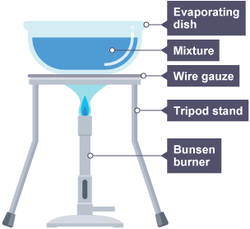

Simple distillation
Distillation separates a liquid from a solution. For example, water can be separated from salty water by simple distillation. This method works because the water evaporates from the solution, but is then cooled and condensed in a condenser and collected in a separate container. The salt does not evaporate and so it stays behind.

Separating a liquid from a solution
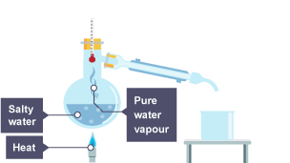

Simple distillation
1. Salty water is heated
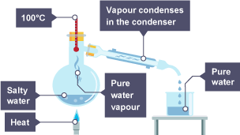

2. The water vapour cools in the condenser and drips into a beaker
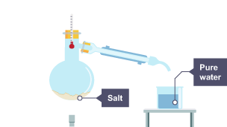

3. The water has condensed and is now in the beaker, the salt stays behind

Paper chromatography
Chromatography can be used to separate mixtures of coloured compounds. Mixtures that are suitable for separation by chromatography include inks, dyes and colouring agents in food.
Simple chromatography is carried out on paper. A spot of the mixture is placed on a pencil line near the bottom of a piece of chromatography paper – the line must be in pencil because pencil is insoluble in water and so will not move as the chromatography progresses. The paper is then placed upright in a suitable solvent, such as water.
As the solvent soaks up the paper, it carries the mixtures with it. Different components of the mixture will move at different rates. This separates the mixture out.
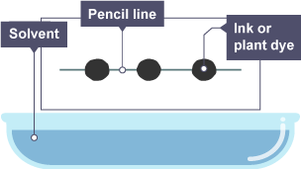

1. Spots of ink or plant dye are placed on a pencil line
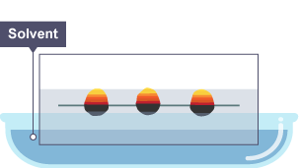

2. As the paper is lowered into the solvent, some of the dye spreads up the paper
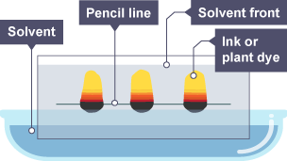

3. The paper has absorbed the solvent, and the dye has spread further up the paper
A pencil line is drawn across a sheet of chromatography paper and spots of ink or plant dye are placed along it. The paper is held above a basin containing solvent. Spots of ink or plant dye are placed on a pencil line

R_{f} values
Different chromatograms and the separated components of the mixtures can be identified by calculating the retardation factor (R_{f}). The R_{f} value is worked out by using this equation:

Key fact
R_{f} = distance moved by the compound ÷ distance moved by the solvent
The R_{f} value is a measure of how soluble a particular substance is in a given solvent. The further the substance moves, the larger the value of R_{f} for that substance, and so the more soluble it is in the solvent that you are using.
The R_{f} value of a particular compound is always the same if the chromatography has been carried out in the same way. This allows industry to use chromatography to identify compounds in mixtures.
Chromatography can also be done when the different substances in the mixture are colourless. The chromatogram can be exposed to a locating agent, which reacts with the invisible chemicals so that they can be seen.
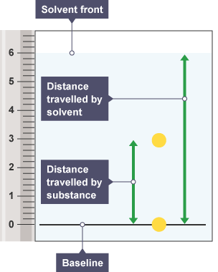
Chromatography paper next to a measurement scale shows distances moved by the solvent and substance
Activity 2
a) Search in the internet how the following separation of mixtures are carried out.
1. Lake Magadi: How Kenyans get salt through evaporation of Trona.
2. Tea factories in Kericho/Limuru: After drying, tea is sieved into grades like BP1, PF1 — that’s mixture separation.
3. Water scarcity: Many communities filter or decant muddy river water to make it safe. This is filtration + sedimentation.
4. Mining: Gold, soda ash, and sand harvesting all depend on separating mixtures.
5. Oil refineries in Mombasa: Fractional distillation of crude oil into petrol, diesel, kerosene.
6. Oxygen is obtained from air.
7. Oil is obtained from sunflower or nuts.

b) Write short notes on your findings. (Put your response)
c) Discuss your findings in groups.
Every time we harvest, cook, clean water, or recycle, we are processing mixtures. The same science used by your grandmother is used by engineers at Magadi, by doctors in labs, and by scientists cleaning up oil spills. Today we learn these techniques so that you can do it better, safer, and maybe build a business from it.

Separating mixtures test questions
- Which substance can be separated from its mixture by filtration?
Water from seawater
Small stones from seawater
Salt from seawater
- Which method is used to obtain copper sulfate crystals from copper sulfate solution?
Filtration
Simple distillation
Crystallisation
- Which method is usually used to separate coloured dyes from each other and identify them?
Chromatography
Simple distillation
Crystallisation
- Where are the spots of the samples placed in chromatography?
Randomly on the piece of paper
In a vertical line on the paper
In a horizontal line on the paper
- Bethan has collected a sample of seawater in a bucket from her local beach. The seawater contains water, salt and sand. Which series of separation techniques could she use to separate and collect the sand, salt and water?
Filtration followed by evaporation
Distillation followed by filtration
Filtration followed by distillation
- A pigment of an ink has an R_{f} value of 0.75, and the solvent front has moved 8 cm. Using the following equation, what is the distance moved by the pigment?
R_{f} value = distance moved by pigment ÷ distance moved by solvent front
0.094 cm
10.667 cm
6 cm
- What is a mixture?
A mixture consists of two or more elements which are chemically joined together
A mixture consists of one or more substances that are not chemically joined together
A mixture consists of two or more substances that are not chemically joined together
- A pigment of an ink moved 4 cm on a piece of chromatography paper, where the solvent front has moved 10 cm. What is the R_{f} value for the pigment?
0.4
2.5
40
- A student wants to separate a mixture of ethanol, olive oil and water using the method of distillation. Ethanol has a boiling point of 78˚C, whilst the boiling point of olive oil is 300˚C. Which substance will be collected first?
Water
Ethanol
Olive oil
- Which statement is true for a chemical change?
No new substances are formed
Energy is always given out or taken in, resulting in a temperature change
It is usually easy to reverse the change

